Out-of-State Registration Renewal Form

Oklahoma Bar Association
Office of the General Counsel
Out-of-State Attorney Registration
PO Box 53036
Oklahoma City, OK 73152-3036
.
.
.
.
.
.
.
.
.

Case Style and Number: _______________________________________________________________________
_______________________________________________________________________

Name and Address of Out-of-State Counsel: _______________________________________________
_______________________________________________
_______________________________________________
_______________________________________________
(Please check all that apply and complete all subsections applicable.)

1.____ the information on the original verified application has not changed and is currently true and accurate as of this present day.
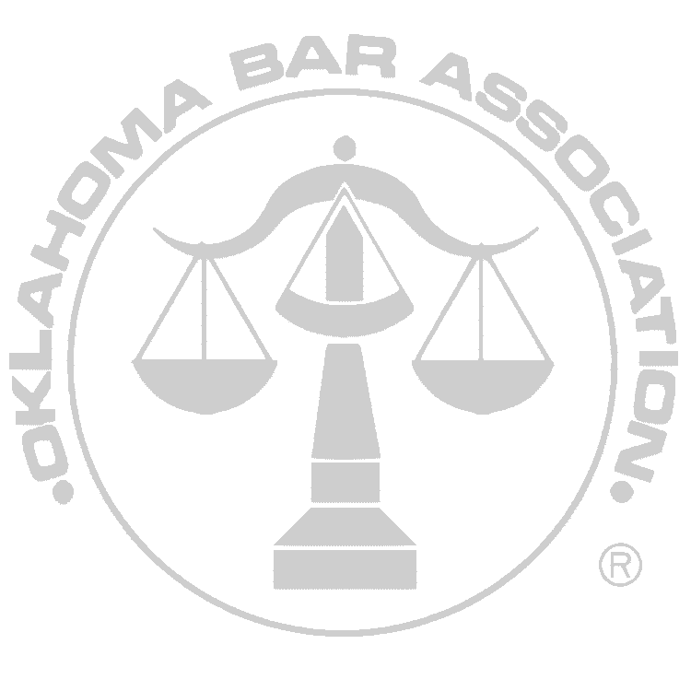

2.____ the case remains pending before an Oklahoma court. A check payable to the Oklahoma Bar Association in the amount of $350.00 representing the annual renewal fee is enclosed.

3.____ the above-referenced out-of-state counsel has withdrawn from this case. Therefore, no renewal fee under 5 O.S. Ch. 1, App. 1, Art. II is applicable.

DATE OUT-OF-STATE COUNSEL WITHDREW: _____________________________*

4.____ the cause has been fully adjudicated.

DATE CASE CLOSED/DISMISSED: __________________________________*

___________________ ___________________________
DATE SIGNATURE

* INCLUDE A COPY OF THE COURT ORDER REFLECTING THE WITHDRAWAL OF THE ATTORNEY/OR DISPOSITION OF THE CASE.

